Competition Guidelines

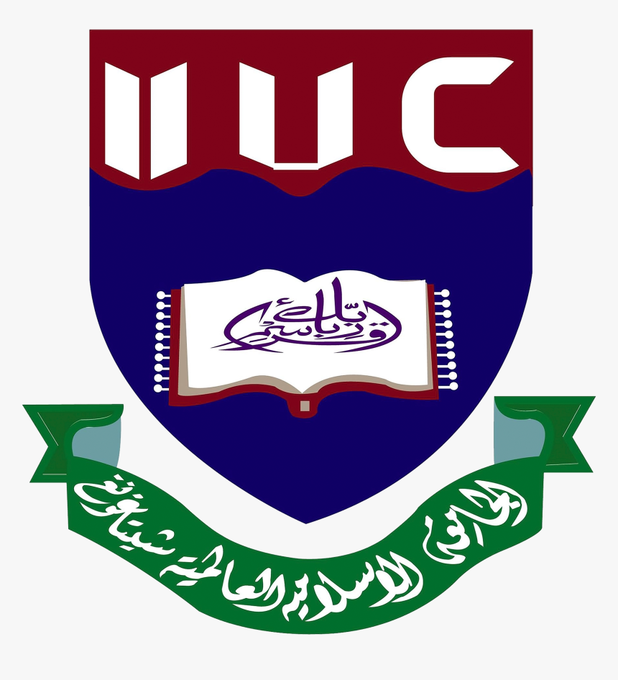
Mechanics Olympiad – Tech Fest 2025
Department of Civil Engineering
International Islamic University Chittagong (IIUC)
Event Type: Intra-University Competition
Event Title: Mechanics Olympiad – Tech Fest 2025

Contest Briefing
Ready to test your logic, speed, and engineering instincts? 💡
The Engineering Mechanics Battle invites students from all departments to step into a challenge where physics meets problem-solving under pressure. Whether you're from Civil, EEE, ETE, CCE, CSE, Pharmacy or any other field, this is your chance to sharpen your analytical edge, outthink your peers, and experience the thrill of competitive engineering.
Crack concepts, dominate diagrams, and unlock glory- because true engineers solve, not guess.
Objective: This contest will allow students to delve into the world of Engineering Mechanics and enjoy its essence, while sharpening their minds and enhancing problem-solving skills.

2. Rules & Regulations
- Eligibility: Open to students of IIUC (Civil/EEE/ETE/CCE/CSE/ Pharmacy and Other Departments).
- Registration Fee: 200 BDT only
- Individual participation only – no teams.
- Participants must bring their IIUC ID card.
- Calculator is ALLOWED (Non-programmable preferred).
- Mobile phones and smart devices are STRICTLY NOT ALLOWED.
- Any form of cheating or malpractice will result in immediate disqualification.
- Participants must be present at least 15 minutes before the exam begins.
Judges’ decisions will be considered final.

3. Exam Format
Stage 1 (Elimination/Final Round):
- Type: Individual
- Total Questions: yet to declare (40% analytical problems, 30% multiple choice questions, 30% Fill in the Gaps)
- Total Marks: 100
- Duration: 60 minutes
Question Types:
- MCQ
- Fill in the Blanks
- Conceptual statics and dynamics questions
- Short numerical problems
Final Ranking: Top 3 performers from this stage.

4. Exam Syllabus
i. Fundamental Principles of Mechanics: Newton’s laws of motion, Resultant of force systems, Free-body diagrams and equilibrium conditions

ii. Kinematics of Particles and Rigid Bodies: Motion in one, two, and three dimensions, Relative velocity and acceleration, Projectile motion and circular motion, Rotational motion of rigid bodies

iii. Dynamics of Particles and Systems: Force, mass, and acceleration, Momentum, impulse, and conservation laws, Work, energy, and power, Applications of energy and momentum principles

iv. Statics of Rigid Bodies : Moment of a force and couples, Equilibrium in 2D and 3D, Centroid, center of gravity, and moment of inertia, Simple trusses, beams, and frames

v. Friction: Laws of dry friction, Problems involving inclined planes, ladders, and wedges, Rolling resistance and pulley systems

vi. Rotational Motion: Torque and angular momentum, Rotational kinetic energy, Rolling motion (pure and with slipping)

vii. Mechanical Vibrations (Basic Concepts): Free and forced vibrations, Natural frequency and damping, Simple spring–mass systems

viii. Work, Energy, and Power : Work-energy principle, Efficiency and energy loss due to friction

ix. Applied and Experimental Mechanics: Determining center of gravity and moment of inertia, Friction and impact experiments, Simple vibration and pendulum setups)
x. Common Problem Areas: Force and equilibrium problems, Statics: truss, beam, and frame analysis, Dynamics: velocity, acceleration, and motion problems, Pulley and machine problems (mechanical advantage and efficiency).

5. Prize Categories
1st | 4000 BDT
2nd | 3500 BDT
3rd | 2500 BDT

